Exercise Javascript Conditions

**Evaluated skills :**

*→ First try on conditions*

What are we going to try to do? Something very simple: provide a comment depending on the age of the person. You must provide a comment on four different age groups that are:

|  |  |
| --- | --- |
| Age range | Comment |
| [1-17] years old | You are not yet an adult |
| [18-49] years old | You are an adult but not yet a senior |
| [50-59] years old | you are a senior but not yet retired |
| [60-120] years old | you are retired enjoy your free time ! |

The sequence of the code will be as follows:

* The user loads the web page;
* He is then asked to type his age in an interactive window;
* Once the age is provided the user gets a small comment.

The interest of this exercise is not especially to leave a comment for each age group, but especially that you seek to use the most suitable conditional structure and that you can prepare your code for all eventualities.

Correction :

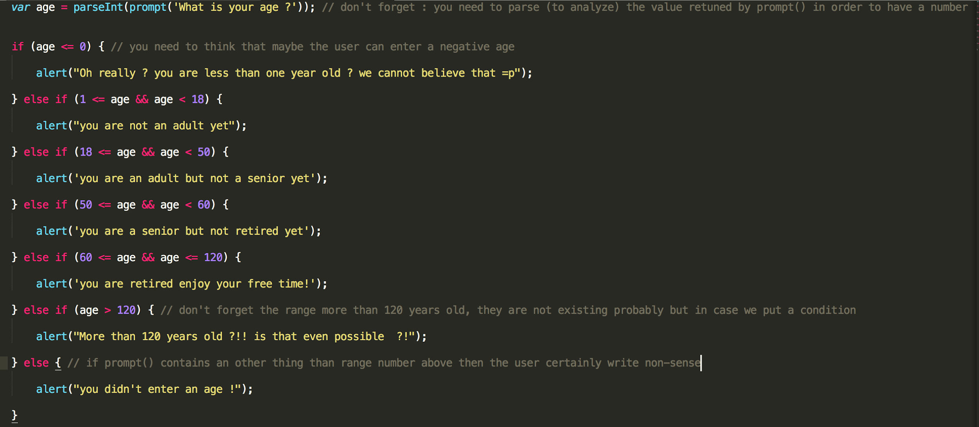

So, did you think about all the eventualities? I have a doubt for the condition else of the structure!

Indeed, the user can choose to not enter a number but any word or phrase, in this case the function parseInt () will not succeed in finding a number and will therefore return the value NaN (evaluated at false) which means Not a Number. Our different conditions will not be verified and the structure will finally be executed, that’s why we are warning the user that he has not entered a number.